The Algorithm
Detecting whether a graph has an Eulerian tour or circuit is actually easy; two different rules apply.
- A graph has an Eulerian circuit if and only if it is connected (once you throw out all nodes of degree 0) and every node has `even degree'.
- A graph has an Eulerian path if and only if it is connected and every node except two has even degree.
- In the second case, one of the two nodes which has odd degree must be the start node, while the other is the end node.
The basic idea of the algorithm is to start at some node the graph and determine a circuit back to that same node. Now, as the circuit is added (in reverse order, as it turns out), the algorithm ensures that all the edges of all the nodes along that path have been used. If there is some node along that path which has an edge that has not been used, then the algorithm finds a circuit starting at that node which uses that edge and splices this new circuit into the current one. This continues until all the edges of every node in the original circuit have been used, which, since the graph is connected, implies that all the edges have been used, so the resulting circuit is Eulerian.
More formally, to determine a Eulerian circuit of a graph which has one, pick a starting node and recurse on it. At each recursive step:
- Pick a starting node and recurse on that node. At each step:
  - If the node has no neighbors, then append the node to the circuit and return
  - If the node has a neighbor, then make a list of the neighbors and process them (which includes deleting them from the list of nodes on which to work) until the node has no more neighbors
  - To process a node, delete the edge between the current node and its neighbor, recurse on the neighbor, and postpend the current node to the circuit.
And here's the pseudocode:
# circuit is a global array
find_euler_circuit
circuitpos = 0
find_circuit(node 1)

# nextnode and visited is a local array
# the path will be found in reverse order
find_circuit(node i)

if node i has no neighbors then
circuit(circuitpos) = node i
circuitpos = circuitpos + 1
else
while (node i has neighbors)
pick a random neighbor node j of node i
delete_edges (node j, node i)
find_circuit (node j)
circuit(circuitpos) = node i
circuitpos = circuitpos + 1
To find an Eulerian tour, simply find one of the nodes which has odd degree and call find_circuit with it.
Both of these algorithms run in O(m + n) time, where m is the number of edges and n is the number of nodes, if you store the graph in adjacency list form. With larger graphs, there's a danger of overflowing the run-time stack, so you might have to use your own stack.

Execution Example
Consider the following graph:
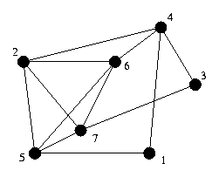
Assume that selecting a random neighbor yields the lowest numbered neighbor, the execution goes as follows:
Stack:
Location: 1
Circuit:

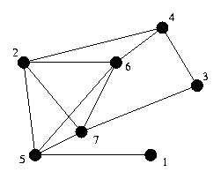 | Stack: 1  Location: 4  Circuit:

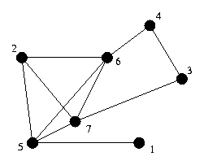 | Stack: 1 4  Location: 2  Circuit:

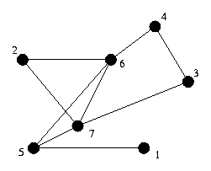 | Stack: 1 4 2  Location: 5  Circuit:

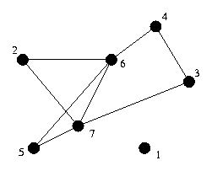 | Stack: 1 4 2 5  Location: 1  Circuit:

Stack: 1 4 2
Location: 5
Circuit: 1

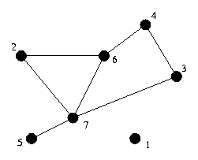 | Stack: 1 4 2 5  Location: 6  Circuit: 1

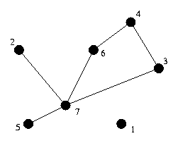 | Stack: 1 4 2 5 6  Location: 2  Circuit: 1

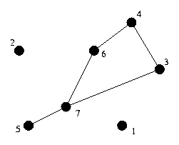 | Stack: 1 4 2 5 6 2  Location: 7  Circuit: 1

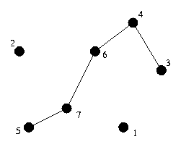 | Stack: 1 4 2 5 6 2 7  Location: 3  Circuit: 1

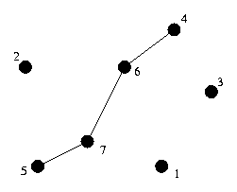 | Stack: 1 4 2 5 6 2 7 3  Location: 4  Circuit: 1

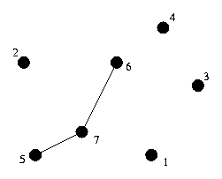 | Stack: 1 4 2 5 6 2 7 3 4  Location: 6  Circuit: 1

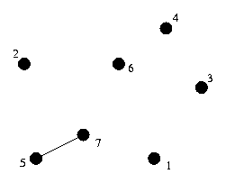 | Stack: 1 4 2 5 6 2 7 3 4 6  Location: 7  Circuit: 1

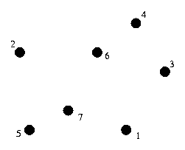 | Stack: 1 4 2 5 6 2 7 3 4 6 7  Location: 5  Circuit: 1

Stack: 1 4 2 5 6 2 7 3 4 6
Location: 7
Circuit: 1 5

Stack: 1 4 2 5 6 2 7 3 4
Location: 6
Circuit: 1 5 7

Stack: 1 4 2 5 6 2 7 3
Location: 4
Circuit: 1 5 7 6

Stack: 1 4 2 5 6 2 7
Location: 3
Circuit: 1 5 7 6 4

Stack: 1 4 2 5 6 2
Location: 7
Circuit: 1 5 7 6 4 3

Stack: 1 4 2 5 6
Location: 2
Circuit: 1 5 7 6 4 3 7

Stack: 1 4 2 5
Location: 6
Circuit: 1 5 7 6 4 3 7 2

Stack: 1 4 2
Location: 5
Circuit: 1 5 7 6 4 3 7 2 6

Stack: 1 4
Location: 2
Circuit: 1 5 7 6 4 3 7 2 6 5

Stack: 1
Location: 4
Circuit: 1 5 7 6 4 3 7 2 6 5 2

Stack:
Location: 1
Circuit: 1 5 7 6 4 3 7 2 6 5 2 4

Stack:
Location:
Circuit: 1 5 7 6 4 3 7 2 6 5 2 4 1

